History of Psychology: Create a Meme on an Area of Psychology Project
Name
Institution Affiliation
Author’s Note
Class
Professor
Date

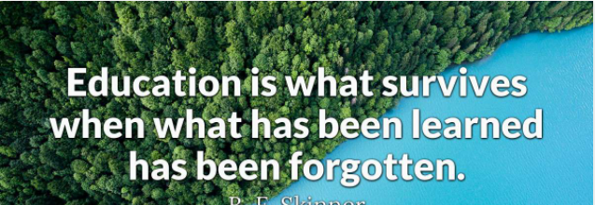
Meme from B. F Skinner: Retrieved from: https://www.brainyquote.com/quotes/b_f_skinner_100064
Explanation of the meme
B. F. Skinner stated that education is regarded as what really remains once a person forgets what one had learned about a particular topic. For instance, a topic on mathematics that would involve learning on certain formulas and particular calculations, the education part would be evident whenever one forgets the calculations he did but can be able to remember the formula and maybe apply it in solving some of the mathematical problems (BrainyQuote, 2020). That would be an instance of education.
The relevance of the quote in psychology can be in a teaching scenario where learners who know where to start, when and how to do a particular learning based on what one can remember. The application of the quote can as well be on the ranking of one’s education on a particular issue. Whenever one is able to remember more then one is seen to be more educated (BrainyQuote, 2020). The education would be echoed by more people to be one of the best. The learning psychology fits into the given quote from Skinner who seemed to base his inventions and theories on learning.
The main reason as to why I used the quote was to bring out the issue of learning and education since everyday it is believed that one learns something new but we would be disadvantaged by the rate of forgetting (BrainyQuote, 2020). However, the quote seems to justify the issue of forgetting since the only important part would be what remains after we forget. Therefore, learning more and more shapes our education in that we might forget little of what we have learned and that would depict us as more educated.

Reference
BrainyQuote. (2020). B. F. Skinner quotes. BrainyQuote. https://www.brainyquote.com/quotes/b_f_skinner_100064
NB: Please remember to delete this part before submission
Hello my friend. First of all I want to thank you so much for trusting me with your work. However, I am glad to admit that I am much honored to work with you and I would like you to take a look at the work and see if it meets your expectations. If so, kindly remember to release the funds on time and leave a rating. Also, you can get me on (kikuvidavy774@gmail.com) in case you need any help in the future. Kindly feel free and let me know of anything and I will be at your service. Again, thank you do much for being patient.

